Network Security Assignment 3

VIDIT PRASHANT GALA
252IS012

ANALYSIS OF THE BLOCK MODES OF OPERATION

1. Electronic Code Book (ECB) -
Code:
def split_blocks(data, block_size=8):
return [data[i:i+block_size] for i in range(0, len(data), block_size)]

from Crypto.Cipher import DES
from Crypto.Util.Padding import pad, unpad

def ecb_encrypt_manual(plaintext, key):
plaintext = pad(plaintext, 8)
blocks = split_blocks(plaintext, 8)
ciphertext = b''
for block in blocks:
cipher = DES.new(key, DES.MODE_ECB)
ciphertext += cipher.encrypt(block)
return ciphertext

def ecb_decrypt_manual(ciphertext, key):
blocks = split_blocks(ciphertext, 8)
plaintext = b''
for block in blocks:
cipher = DES.new(key, DES.MODE_ECB)
plaintext += cipher.decrypt(block)
return unpad(plaintext, 8)

key = b'8bytekey'
msg1 = b'MeetTomorrowAT8'

ct1 = ecb_encrypt_manual(msg1, key)
pt1 = ecb_decrypt_manual(ct1, key)
print("Ciphertext = ", ct1.hex(), "Message Decrypted = ", pt1)
Working:
A Message is divided into multiple fixed size blocks. Then a single plaintext block is encrypted with the key using DES/AES, which then becomes a ciphertext block.
DES_Encrypt[Mi + Key(K)] = Ci
Where Mi = message block i, Ci = ciphertext block i

Weakness:
- Problem with ECB mode of operation is that two same message blocks will give exactly the same ciphertext blocks. This can be a lot helpful for the attacker to create/analyze patterns based on the same ciphertext blocks.
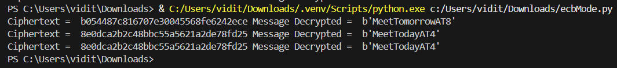

- Another problem with ECB mode of operation is that the attacker can rearrange ciphertext blocks which will create problems for the victim.
plaintext_attack = b'BLOCKONEBLOCKTWOBLOCKTHR'
ciphertext_attack = ecb_encrypt_manual(plaintext_attack, key)
print("\nOriginal Plaintext:", plaintext_attack)
print("Original Ciphertext:", ciphertext_attack.hex())
blocks = split_blocks(ciphertext_attack, 8)
print("\nCiphertext Blocks:")

for i, block in enumerate(blocks):
print(f"Block {i+1}:", block.hex())

tampered_ciphertext = blocks[1] + blocks[0] + blocks[2] + blocks[3]
print("\nTampered Ciphertext:", tampered_ciphertext.hex())
tampered_message = ecb_decrypt_manual(tampered_ciphertext, key)
print("\nDecrypted Tampered Plaintext:", tampered_message)

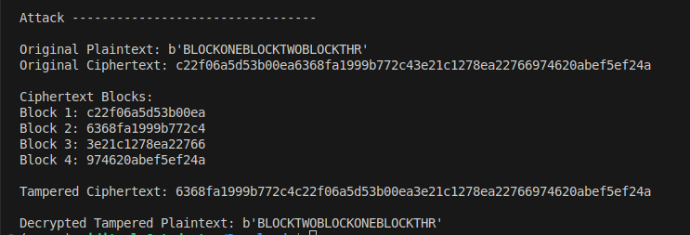

2. Cipher Block Chaining (CBC) -
Code:
def split_blocks(data, block_size=8):
return [data[i:i+block_size] for i in range(0, len(data), block_size)]

from Crypto.Cipher import DES
from Crypto.Util.Padding import pad, unpad
from Crypto.Random import get_random_bytes

def xor_bytes(a, b):
return bytes(x ^ y for x, y in zip(a, b))

def des_encrypt_block(block, key):
cipher = DES.new(key, DES.MODE_ECB)
return cipher.encrypt(block)

def des_decrypt_block(block, key):
cipher = DES.new(key, DES.MODE_ECB)
return cipher.decrypt(block)

def cbc_encrypt_manual(plaintext, key, iv):
plaintext = pad(plaintext, 8)
blocks = split_blocks(plaintext)
ciphertext = b''
prev = iv
for block in blocks:
x = xor_bytes(block, prev)
c = des_encrypt_block(x, key)
ciphertext += c
prev = c
return ciphertext

def cbc_decrypt_manual(ciphertext, key, iv):
blocks = split_blocks(ciphertext)
plaintext = b''
prev = iv
for block in blocks:
p = xor_bytes(des_decrypt_block(block, key), prev)
plaintext += p
prev = block
return unpad(plaintext, 8)

key = b'8bytekey'
iv = get_random_bytes(8)
msg = b'Secret meet at Palace'

ciphertext = cbc_encrypt_manual(msg, key, iv)
plaintext = cbc_decrypt_manual(ciphertext, key, iv)

print("IV :", iv.hex())
print("Ciphertext:", ciphertext.hex())
print("Plaintext :", plaintext)

Working:
In CBC mode of operation a message is broken into blocks and then it is encrypted using DES.

DES_Encrypt[(Mi XOR Ci-1) + Key(K)] = Ci
Where Mi = message block i, Ci = ciphertext block i, Ci-1 = ciphertext block i-1(just before i), If i = 1, Ci-1 = IV(Initialization vector)

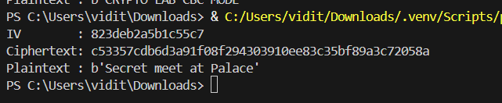

Weakness:
In CBC mode, plaintext is recovered as:

Pi = Decrypt(Ci) XOR Ci-1
Where Pi = plaintext block i, Ci = ciphertext block i, Ci-1 = ciphertext block i-1(just before i), XOR = xor(^) operation

- If the same IV is used for each message block, then for the same message the mode of operation it will generate the same ciphertext blocks.
- An attacker cannot control the decryption Decrypt(Ci), but they can modify the previous ciphertext block Ci−1​. By flipping selected bits in Ci−1​, the attacker causes predictable bit changes in the decrypted plaintext block Pi​. This allows modification of encrypted data without knowing the secret key.
plaintext = b"userid=10;user=false;"
ciphertext = cipher.encrypt(pad(plaintext, 8))
print("Original plaintext:", plaintext)

# --- Attacker side ---
ciphertext = bytearray(ciphertext)
ciphertext[8 + 0] ^= ord('f') ^ ord('t')
ciphertext[8 + 1] ^= ord('a') ^ ord('r')
ciphertext[8 + 2] ^= ord('l') ^ ord('u')
ciphertext[8 + 3] ^= ord('s') ^ ord('e')
ciphertext[8 + 4] ^= ord('e') ^ ord(' ')

# --- Victim decrypts ---
decipher = DES.new(key, DES.MODE_CBC, iv)
decrypted = unpad(decipher.decrypt(ciphertext), 8)
print("Tampered plaintext:", decrypted)
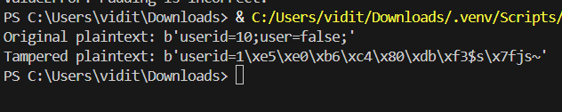
Hence, CBC provides confidentiality but not integrity and is vulnerable to bit-flipping attacks.
3. Cipher Feedback (CFB) -
Code:
def split_blocks(data, block_size=8):
return [data[i:i+block_size] for i in range(0, len(data), block_size)]

from Crypto.Cipher import DES
from Crypto.Random import get_random_bytes

def xor_bytes(a, b):
return bytes(x ^ y for x, y in zip(a, b))

def des_encrypt_block(block, key):
cipher = DES.new(key, DES.MODE_ECB)
return cipher.encrypt(block)

def cfb_encrypt_manual(plaintext, key, iv):
blocks = split_blocks(plaintext)
ciphertext = b''
prev = iv
for block in blocks:
keystream = des_encrypt_block(prev, key)
c = xor_bytes(block, keystream)
ciphertext += c
prev = c
return ciphertext

def cfb_decrypt_manual(ciphertext, key, iv):
blocks = split_blocks(ciphertext)
plaintext = b''
prev = iv
for block in blocks:
keystream = des_encrypt_block(prev, key)
p = xor_bytes(block, keystream)
plaintext += p
prev = block
return plaintext

key = b'8bytekey'
iv = get_random_bytes(8)
msg = b'Transfer=1000USD'
print("Original message = ", msg)

ciphertext = cfb_encrypt_manual(msg, key, iv)
plaintext = cfb_decrypt_manual(ciphertext, key, iv)

print("IV :", iv.hex())
print("Ciphertext:", ciphertext.hex())
print("Plaintext :", plaintext)

Working:
CFB mode of operation works as:

[(DES_Encrypt[Ci-1 + Key(K)])k-bits XOR Pi] = Ci
Where Pi = plaintext block i, Ci = ciphertext block i, Ci-1 = ciphertext block i-1(just before i). If i=1, Ci-1 = IV(Initialization vector)

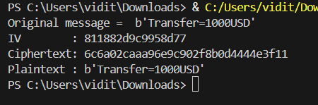

Weakness:
In CFB mode plaintext is recovered as:

Pi = Ci XOR Encrypt(Ci-1)
Where Pi = plaintext block i, Ci = ciphertext block i, Ci-1 = ciphertext block i-1(just before i), XOR = xor(^)

- It is the slowest mode of operation.

- If an attacker flips selected bits in a ciphertext block, the same bits flip predictably in the decrypted plaintext block. Thus this also corrupts the next plaintext block and the attacker can modify sensitive fields such as amounts or flags.
# ---- attacker ----
ciphertext = bytearray(ciphertext)
ciphertext[9] ^= ord('1') ^ ord('9')

# ---- receiver ----
decrypted = cfb_decrypt_manual(ciphertext, key, iv)
print("Tampered plaintext:", decrypted)

Since CFB provides no message authentication, the receiver cannot detect this tampering.
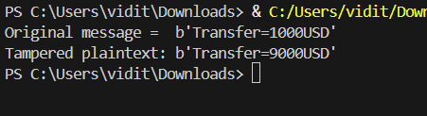

Error Propogating attack:
msg = b'Transfer=1000USD;Transfer=2000USD;Transfer=3000USD'
ciphertext[12] ^= 0xFF

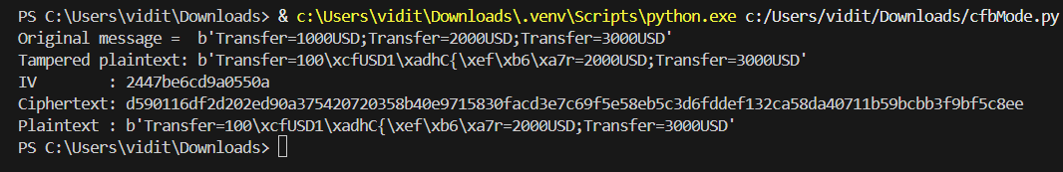
Therefore, CFB mode ensures confidentiality but not integrity and is vulnerable to bit-flipping attacks.

4. Output Feedback (OFB) -
Code:
def split_blocks(data, block_size=8):
return [data[i:i+block_size] for i in range(0, len(data), block_size)]

from Crypto.Cipher import DES
from Crypto.Util.Padding import pad, unpad
from Crypto.Random import get_random_bytes

def xor_bytes(a, b):
return bytes(x ^ y for x, y in zip(a, b))

def des_encrypt_block(block, key):
cipher = DES.new(key, DES.MODE_ECB)
return cipher.encrypt(block)

def des_decrypt_block(block, key):
cipher = DES.new(key, DES.MODE_ECB)
return cipher.decrypt(block)

def ofb_encrypt_manual(data, key, iv):
blocks = split_blocks(data)
result = b''
stream = iv
for block in blocks:
stream = des_encrypt_block(stream, key)
result += xor_bytes(block, stream[:len(block)])
return result

def ofb_decrypt_manual(data, key, iv):
blocks = split_blocks(data)
result = b''
stream = iv
for block in blocks:
stream = des_encrypt_block(stream, key)
result += xor_bytes(block, stream)
return result

key = b'8bytekey'
iv = get_random_bytes(8)
msg = b'Output Feedback Mode'

ciphertext = ofb_encrypt_manual(msg, key, iv)
plaintext = ofb_decrypt_manual(ciphertext, key, iv)

print("IV :", iv.hex())
print("Ciphertext:", ciphertext.hex())
print("Plaintext :", plaintext)

Working:
In OFB mode of operation a message is divided into multiple fixed size blocks which are then encrypted one by one.

[(DES_Encrypt[IV + Key(K)])k-bits XOR Pi] = Ci
Where Pi = plaintext block i, Ci = ciphertext block i, IV = Initialization vector, XOR = xor(^)
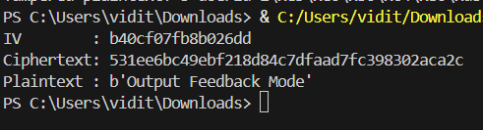
Weakness:
- Attacker knows the ciphertexts, it tries to gain information about the plaintexts, so OFB has same key and same IV, this helps the attacker to know that:

Ci XOR Ci+1 = Pi XOR Pi+1
Where Ci = ciphertext block i, Ci+1 = ciphertext block i+1(just after i), Pi = plaintext block i, Pi+1 = plaintext block i+1(just after i), XOR = xor(^)

If the attacker knows any plaintext–ciphertext pair(Ci, Pi) and another ciphertext Ci+1. Thus by using Ci, Ci+1 and Pi, attacker can know Pi+1, and they can gain a lot of information in this manner.

recovered = bytes(a ^ b ^ c for a, b, c in zip(ciphertext1, ciphertext2, p1))
print("Attacker tries to get the plaintext 2 by using Ciphertext1, Ciphertext2 and Plaintext1")
print(recovered)
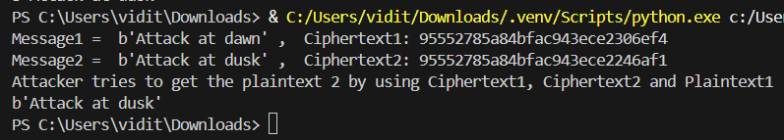

5. Counter (CTR) -
Code:
def split_blocks(data, block_size=8):
return [data[i:i+block_size] for i in range(0, len(data), block_size)]

from Crypto.Cipher import DES
from Crypto.Util.Padding import pad, unpad
from Crypto.Random import get_random_bytes

def xor_bytes(a, b):
return bytes(x ^ y for x, y in zip(a, b))

def des_encrypt_block(block, key):
cipher = DES.new(key, DES.MODE_ECB)
return cipher.encrypt(block)

def des_decrypt_block(block, key):
cipher = DES.new(key, DES.MODE_ECB)
return cipher.decrypt(block)

def int_to_bytes(n):
return n.to_bytes(8, 'big')

def ctr_encrypt_manual(data, key, nonce):
blocks = split_blocks(data)
result = b''
counter = 0
for block in blocks:
counter_block = xor_bytes(nonce, int_to_bytes(counter))
keystream = des_encrypt_block(counter_block, key)
result += xor_bytes(block, keystream)
counter += 1
return result

def ctr_decrypt_manual(data, key, nonce):
blocks = split_blocks(data)
result = b''
counter = 0
for block in blocks:
counter_block = xor_bytes(nonce, int_to_bytes(counter))
keystream = des_encrypt_block(counter_block, key)
result += xor_bytes(block, keystream)
counter += 1
return result

key = b'8bytekey'
iv = get_random_bytes(8)
msg = b'Pay=1000USD'
print("Original Message = ", msg)
ciphertext = ctr_encrypt_manual(msg, key, iv)
print("IV :", iv.hex())
print("Ciphertext:", ciphertext.hex())
print("Plaintext :", plaintext)

Working:
Counter mode of operation works as:

(DES_Encrypt[(IV+i) + Key(K)] XOR Pi) = Ci
Where Ci = ciphertext block i, Pi = plaintext block i, IV+i = Initialization vector + i, XOR = xor(^)

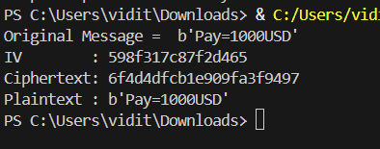

Weakness:
In CTR mode,

C = P XOR keystream
Where C = cipher, P = plaintext

If the same counter value is reused with the same key, the identical keystream is produced again. An attacker can flip bits in the ciphertext to cause predictable changes in the decrypted plaintext.
# -------- Attacker flips bits --------
ciphertext = bytearray(ciphertext)
ciphertext[4] ^= ord('1') ^ ord('9')

plaintext = ctr_decrypt_manual(ciphertext, key, iv)
print("Tampered plaintext :", plaintext)
This allows message modification or plaintext recovery without knowing the encryption key.
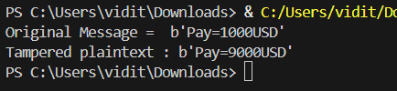
Since CTR mode provides no integrity protection, such tampering cannot be detected.

